SQL QUERY :

1. Create Table Name : Student and Exam

create table Student (Rollno int primary key, Name char(10), Branch varchar(20));

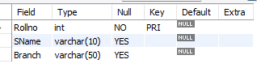

create table Exam (Rollno int references Student(Rollno), S_code varchar(10), Marks int, P_code varchar(5));

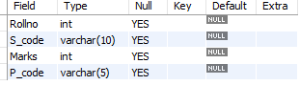

insert into Student values (1,’Jay’,’Computer Science’),

(2,’Suhani’,’Electonic and Com’),

(3,’Kriti’,’Electronic and Com’);

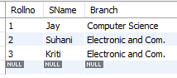

Insert into exam values

(1,’CS11’,50,’CS’),

(1,’CS12’,60,’CS’),

(2,’EC101’,66,’EC’),

(2,’EC102’,70,’EC’),

(3,’EC101’,45,’EC’),

(3,’EC102’,50,’EC’);

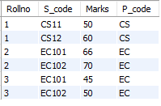

1. Create table given below: Employee and IncentiveTable.

CREATE TABLE Employee(Employee_id int primary key, First_name char(15), Last_name char(15), Salary int, Joining_date datetime, Department char(20));

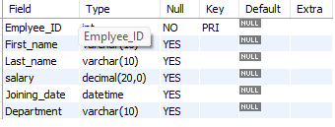

CREATE TABLE Incentive(Employee_ref_id int, Incentive_date date, Incentive_amount int);

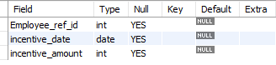

INSERT INTO Employee values

(1,'John','Abraham',1000000,'2013-01-01 12:00:00','Banking'),

(2,'Michael','Clarke',800000,'2013-01-01 12:00:00','Insurance'),

(3,'Roy','Thomas',700000,'2013-02-01 12:00:00','Banking'),

(4,'Tom','Jose',600000,'2013-02-01 12:00:00','Insurance'),

(5,'Jerry','Pinto',650000,'2013-02-01 12:00:00','Insurance'),

(6,'Philip','Mathew',750000,'2013-01-01 12:00:00','Services'),

(7,'TestName1','123',650000,'2013-01-01 12:00:00','Services'),

(8,'TestName2','Lname%',600000,'2013-02-01 12:00:00','Insurance');

Insert into incentive values

(1,’2013-02-01’,5000),

(2,’2013-02-01’,3000),

(3,’2013-02-01’,4000),

(1,’2013-01-01’,4500),

(2,’2013-01-01’,3500);

1. Get First_Name from employee table using Tom name “Employee Name”.

select First_name from employee where First_name = 'Tom';



1. Get FIRST_NAME, Joining Date, and Salary from employee table.

select First_name , Joining_date , salary from employee;

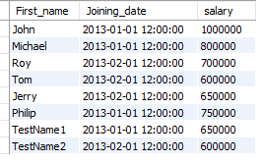

1. Get all employee details from the employee table order by First_Name Ascending and Salary descending?

select * from employee order by First_name asc ;

select * from employee order by salary desc ;

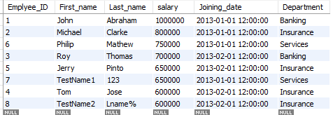

1. Get employee details from employee table whose first name contains ‘J’.

select * from employee where First_name like 'J%';

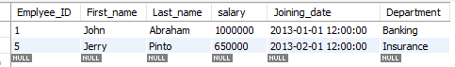

1. Get department wise maximum salary from employee table order by salary ascending?

select Department,max(salary) from employee group by Department;

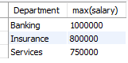

1. Select first_name, incentive amount from employee and incentives table forthose employees who have incentives and incentive amount greater than 3000

select e.First_name,i.incentive_amount from employee e inner join incentive i

on e.Emplyee_ID = i.Employee_ref_id where incentive_amount > 3000;

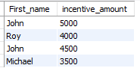

1. Create After Insert trigger on Employee table which insert records in viewtable
2. Create table given below: Salesperson and Customer.

create table Salesperson(SNo int primary key, SName varchar(10),CITY varchar(20),COMM decimal(2,2));

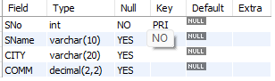

Create table Customer (CNM int primary key, CNAME varchar(10), CITY varchar (10), RAATING int, SNo int references Salesperson(Sno));

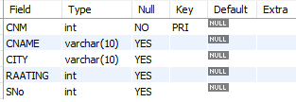

1. Retrieve the below data from above table

Select * from Salesperson s full join Customer c

On s.SNo = c.SNo;

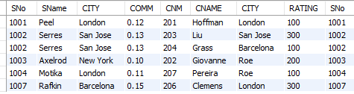

1. All orders for more than $1000.

Select ord_no from orders where purch_amt > 1000;



1. Names and cities of all salespeople in London with commission above 0.12.

Select name,city from Salesperson where city=’London’ and commission > 0.12;



1. All salespeople either in Barcelona or in London.

Select * from Salesperson where city in(‘Barcelona’,’London’);

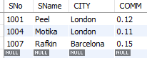

1. All salespeople with commission between 0.10 and 0.12. (Boundary valuesshould be excluded).

Select * from Salesperson where commission between 0.10 and 0.12;

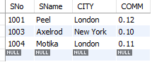

1. All customers excluding those with rating <= 100 unless they are located inRome.

Select * from Customer where rating <= 100 and city != ‘Rome’;

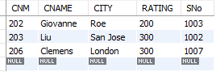

1. Write a SQL statement that displays all the information about all salespeople

Select * from Salesperson;

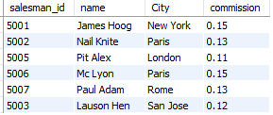

1. From the following table, write a SQL query to find orders that are delivered by a salesperson with ID. 5001. Return ord_no, ord_date, purch_amt.

Select ord_no, ord_date, purch_amt from orders where salesperson_id = 5001;

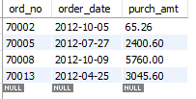

1. From the following table, write a SQL query to select a range of products whose price is in the range Rs.200 to Rs.600. Begin and end values are included. Return pro_id, pro_name, pro_price, and pro_com.

Select * from item_mast where pro_price between 200 and 500;

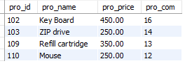

1. From the following table, write a SQL query to calculate the average price for a manufacturer code of 16. Return avg.

Select avg(pro_price) from item_mast where pro_com = 16;



1. From the following table, write a SQL query to display the pro_name as 'Item Name' and pro_priceas 'Price in Rs.'

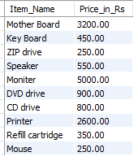

1. From the following table, write a SQL query to find the items whose prices are higher than or equal to $250. Order the result by product price in descending, then product name in ascending. Return pro_name and pro_price.

Select pro_name, pro_price from item_mast where pro_price >= 250 and order by pro_price desc;

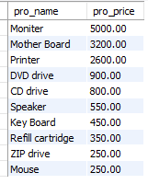

Select pro_name, pro_price from item_mast where pro_price >= 250 and order by pro_name asc;

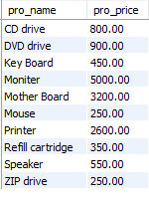

1. From the following table, write a SQL query to calculate average price of the items for each company. Return average price and company code.

Select avg(pro_price),pro_com from item_mast